# **Validation Report Cost-Obj**

## *Summary Report*

*OBJECT*

IfcWall.NOTDEFINED

GlobalId: 1sm_GUAnj8mBnFLn7QxztD

Obj Name: Muro di base:MUR_INT_LT_15_IN1,5_LT12_IN1,5:153159

*COST ITEM*

IfcCostItem

Price List Code: OC.EEA.a02.C0102.L0011.0265.-

GlobalId: 24X$gqt1z1ZeOIEVzvAEP9

Cost Name: Masonry wall thickness 12cm

*CHART*

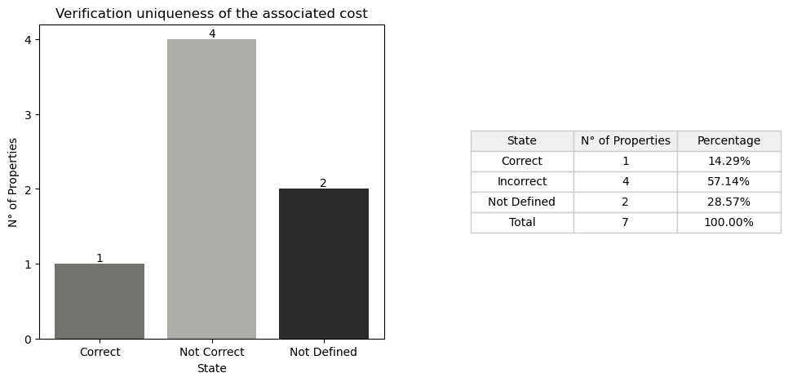

## *Detail Table*

|  |  |  |
| --- | --- | --- |
| **State** | **N° of Properties** | **Properties** |
| Correct | 1 | Entity |
| Incorrect | 4 | TypeEnum IsExternal LoadBearing Width |
| Not Defined in the obj | 2 | Compartimentation Status |
| Not Defined in the cost | 1 | FireRating |
| Not Defined in the cost and obj | 3 | ThermalTrasmittance AcousticRating PitchAngle |

## *Detail Report*

**🔸Number of Correct Properties: 1**

Entity: ✓   
 • #17=IfcWall('0if5M7HxDBe829$EMf6fWm',$,'Sample element of masonry brick wall','Sample element of masonry brick wall',$,$,$,$,.PARTITIONING.)   
 • #3709=IfcWall('1sm_GUAnj8mBnFLn7QxztD',#21,'Muro di base:MUR_INT_LT_15_IN1,5_LT12_IN1,5:153159',$,'Muro di base:MUR_INT_LT_15_IN1,5_LT12_IN1,5',#3704,#3708,'153159',.NOTDEFINED.)

**🔸Number of Incorrect Properties: 4**

TypeEnum: ✗   
 • #17=IfcWall('0if5M7HxDBe829$EMf6fWm',$,'Sample element of masonry brick wall','Sample element of masonry brick wall',$,$,$,$,.PARTITIONING.)   
 • #3709=IfcWall('1sm_GUAnj8mBnFLn7QxztD',#21,'Muro di base:MUR_INT_LT_15_IN1,5_LT12_IN1,5:153159',$,'Muro di base:MUR_INT_LT_15_IN1,5_LT12_IN1,5',#3704,#3708,'153159',.NOTDEFINED.)   
  
IsExternal: ✗   
 • #21=IfcPropertySingleValue('IsExternal','Indication whether the element is designed for use in the exterior (TRUE) or not (FALSE). If (TRUE) it is an external element and faces the outside of the building',IfcBoolean(.F.),$)   
 • #338=IfcPropertySingleValue('IsExternal',$,IfcBoolean(.T.),$)   
  
LoadBearing: ✗   
 • #22=IfcPropertySingleValue('LoadBearing','Whether this component is carrying (YES) or not carrying (NO)',IfcBoolean(.F.),$)   
 • #615=IfcPropertySingleValue('LoadBearing',$,IfcBoolean(.T.),$)   
  
Width: ✗   
 • #26=IfcQuantityLength('Width','Thickness of the wall, the value is given only if the thickness is constant',#3,0.12,$)   
 • #1942=IfcQuantityLength('Width',$,$,0.15000000000000002,$)

**🔸Number of Not Defined Properties in Obj: 2**

Compartimentation: ✗   
 • property not found in OBJ  
  
Status: ✗   
 • property not found in OBJ

**🔸Number of Not Defined Properties in Cost Item: 1**

FireRating: ✗   
 • property not found in COST ITEM

**🔸Number of Not Defined Properties in Cost Item and Obj: 3**

ThermalTrasmittance: ✗   
 • property not found in OBJ and COST ITEM  
  
AcousticRating: ✗   
 • property not found in OBJ and COST ITEM  
  
PitchAngle: ✗   
 • property not found in OBJ and COST ITEM